User Manual

After starting the Apache and MySql modules in the xampp control panel, we enter our browser and type the path http://localhost/coolac/, which will present us with the following screen

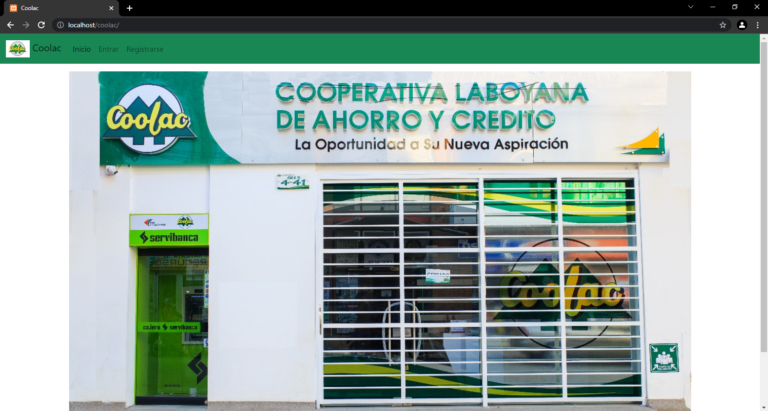

Here we see in the top menu the options Coolac, Home, Login and Register, if we click on the image, Coolac or Home it will take us to the screen above.

If we click on register, it will show us the form with the registration data, after filling them in and clicking on the Register button, if the action was successful it will take us to the login page if not it will show us a message.

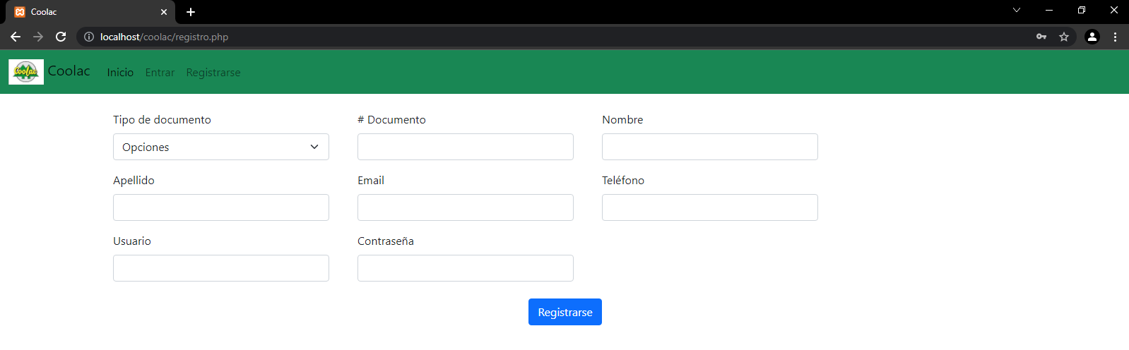

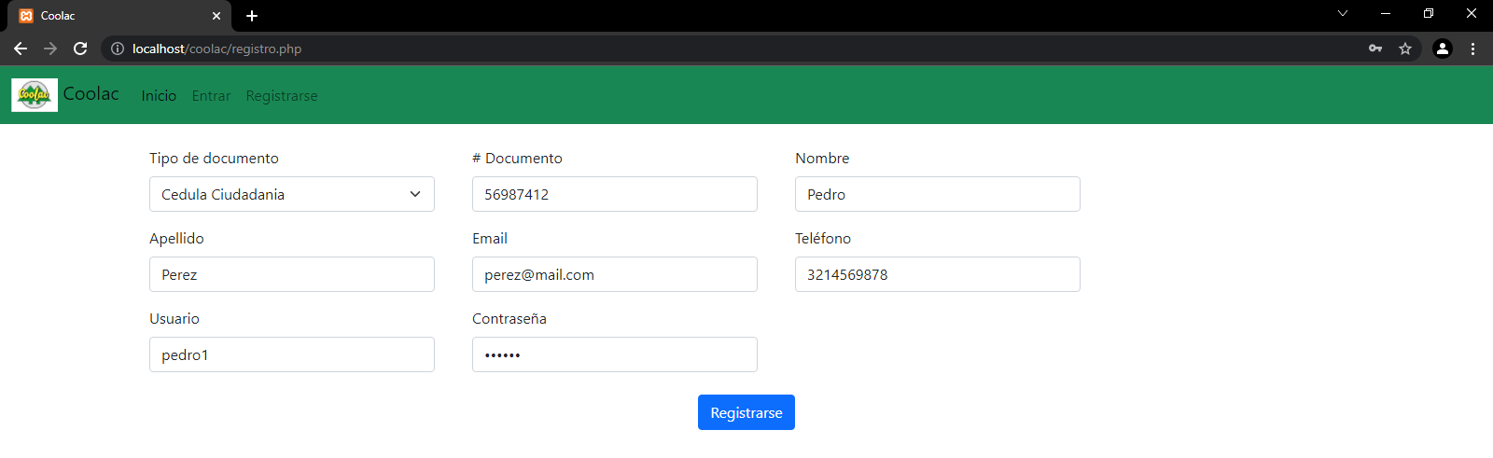

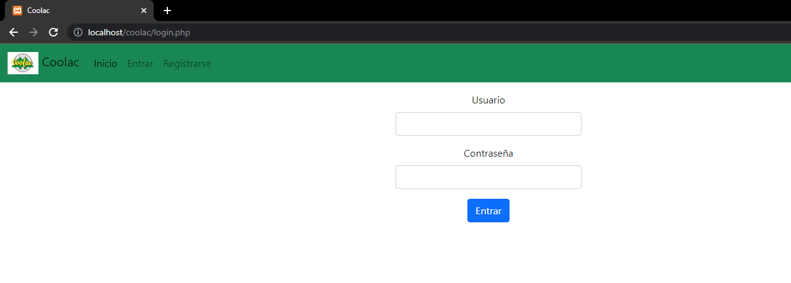

If we click on enter, it will take us to the login page, where the login form will be shown, here we will enter our user and password, which we created when we registered, if the data are correct it will take us to the Home page if not it will show us a message.

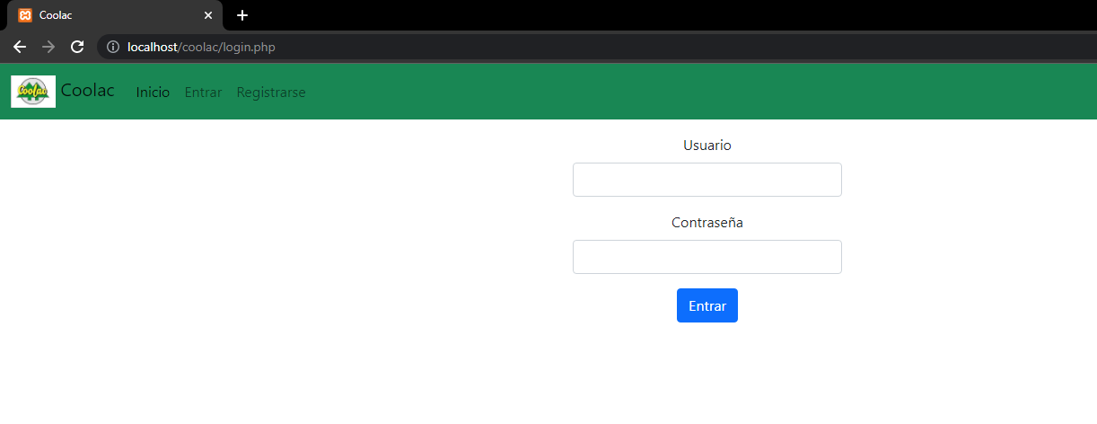

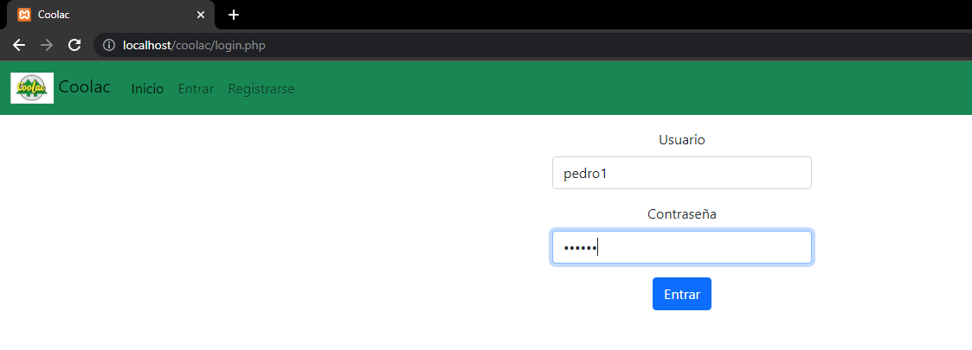

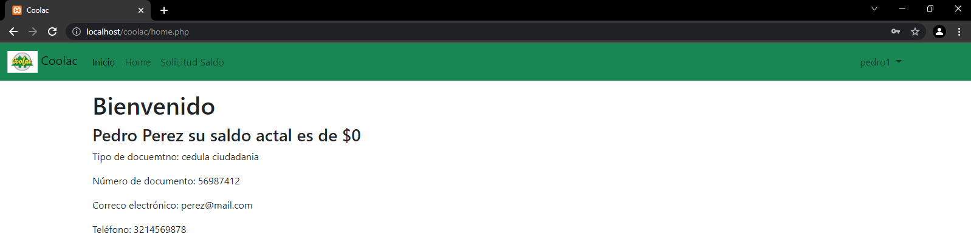

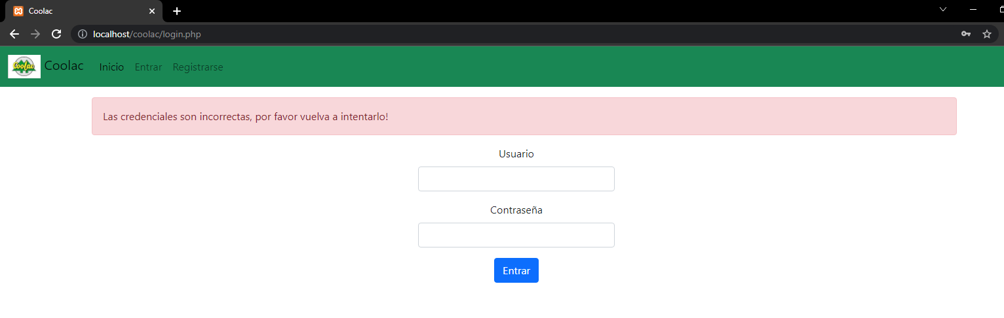

In the Home page it will show us our user's data and if we are users with USUARIO role it will show us the amount of balance we have, we can see that the menu has changed now the options of Coolac, Home, Home, Balance Request and on the right side our user name appears, if we click on our user name in the menu, the option to log out will be displayed and if we click on log out it will take us to the home page.

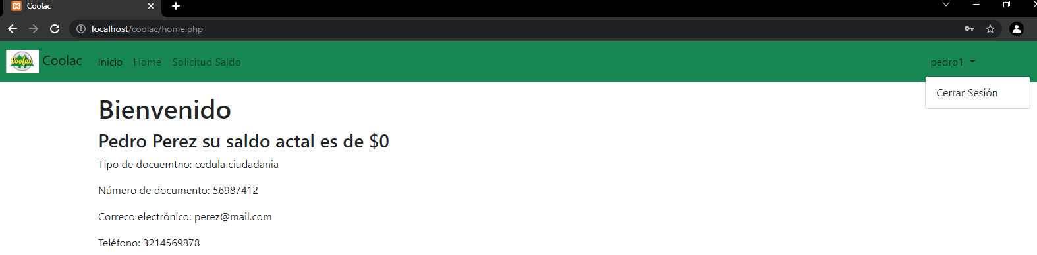

As users with USUARIO role we will be able to make balance requests, which we will do in the Balance Request page by clicking on Balance Request and then within this on the button create balance request, in this page we will be shown a form with the amount we want to request, when typing it and sending the request it will take us back to the Balance Request page where we will visualize the list of balance requests we have made, their respective data and the status of the request.

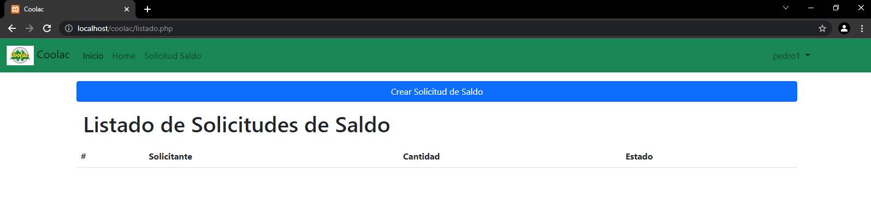

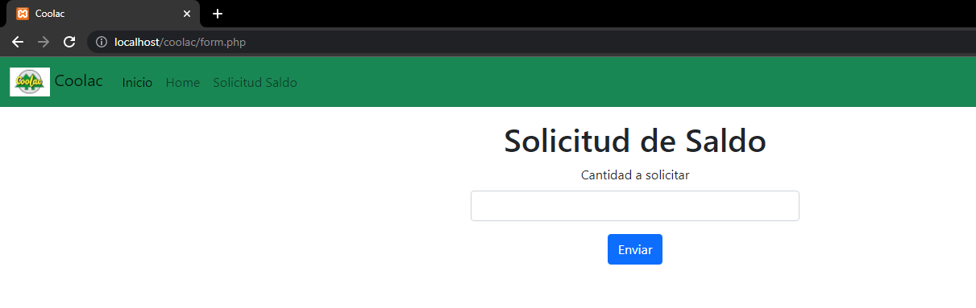

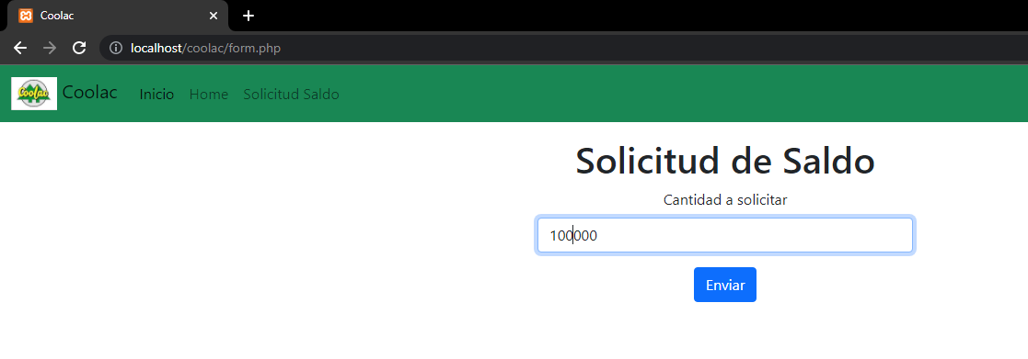

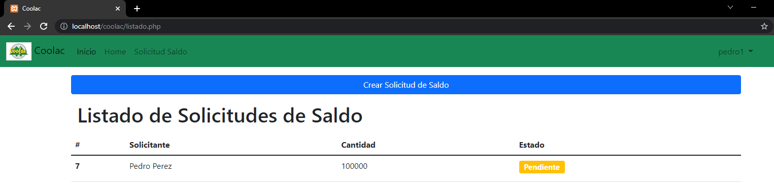

If we enter as a user with ADMINISTRADOR role, it will send us to the Home page, in this page we will see practically the same as if we entered as a user with USUARIO role, only that the balance does not appear in the user data. If we click on Balance Request it will take us to the page of balance request, in this page we will be able to observe the list of all the balance requests made by the users with role USUARIO, in this view we will not see the button to create balance request, because the administrators cannot make requests, but in the list visualization we will be able to observe a new column called action, When clicking on any of the two buttons will show a confirmation window of the action, when confirmed the status of the request changes to action and if approved the balance of the requesting user will increase by that amount.

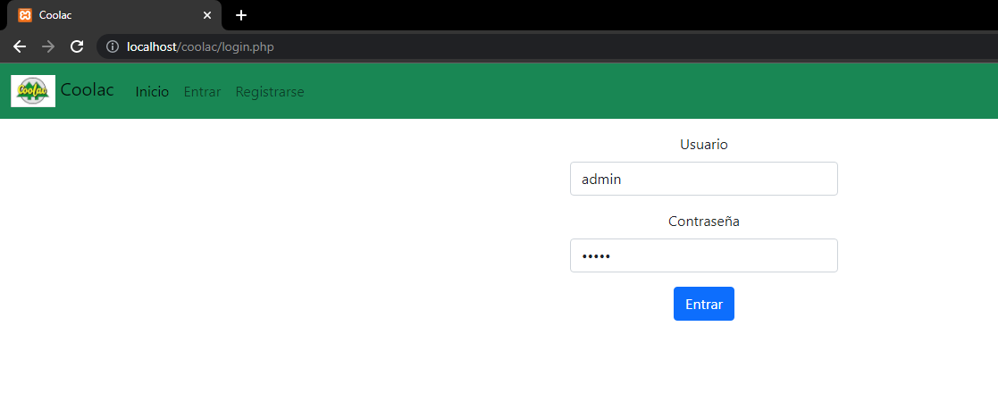

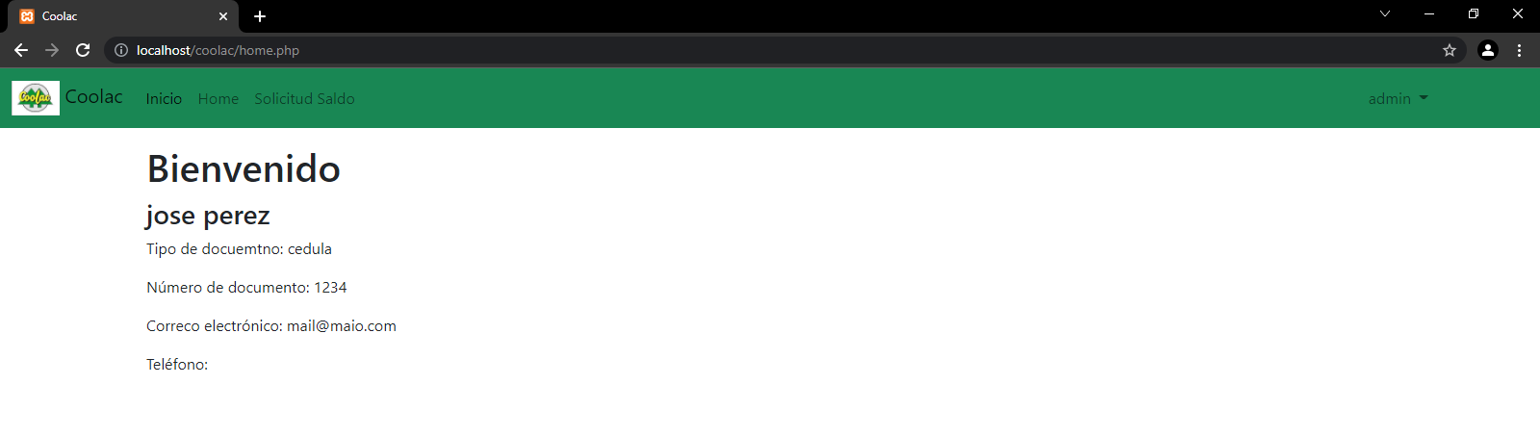

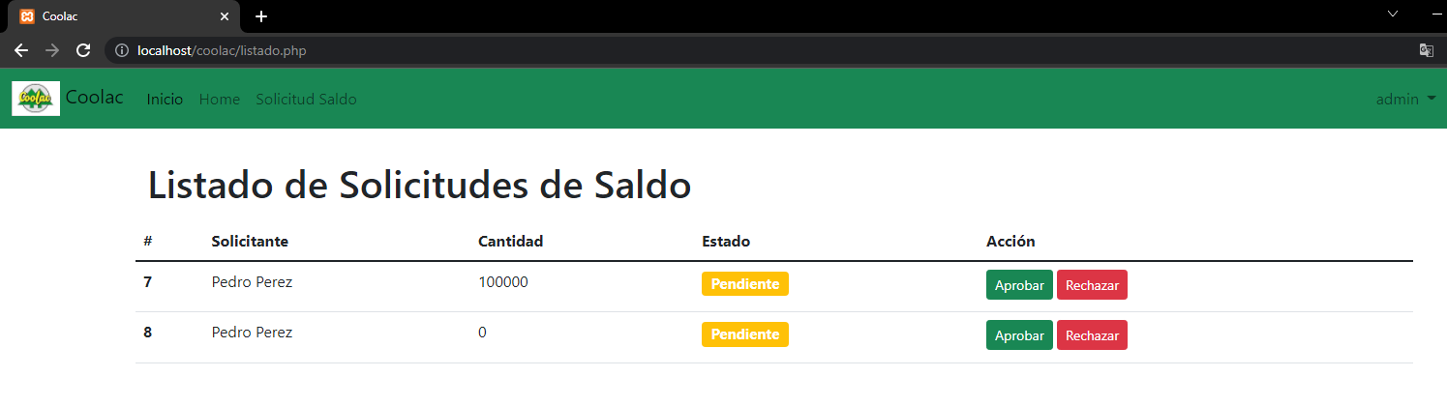

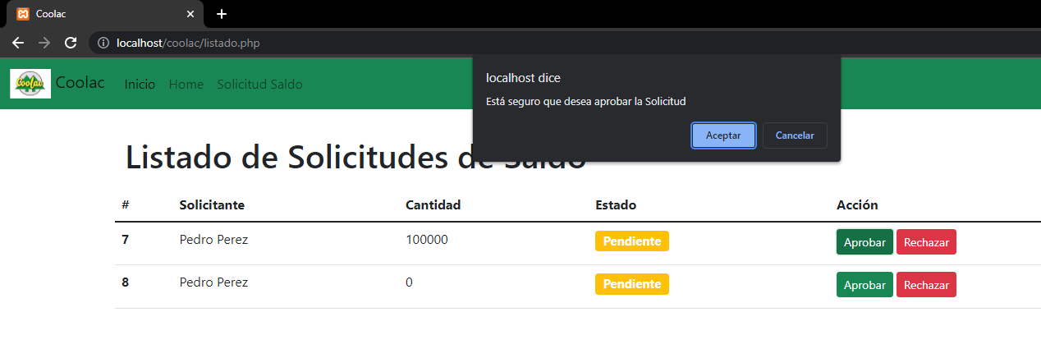

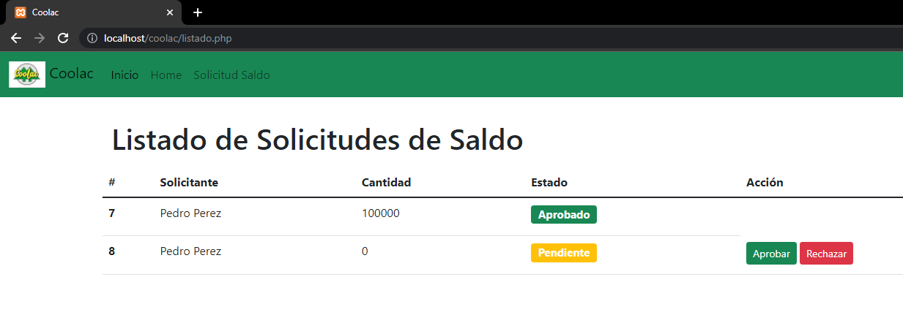

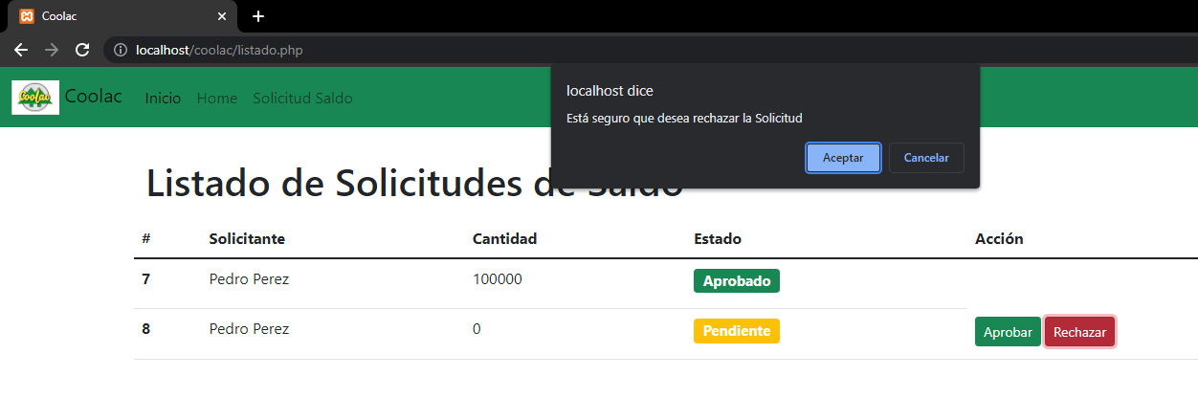

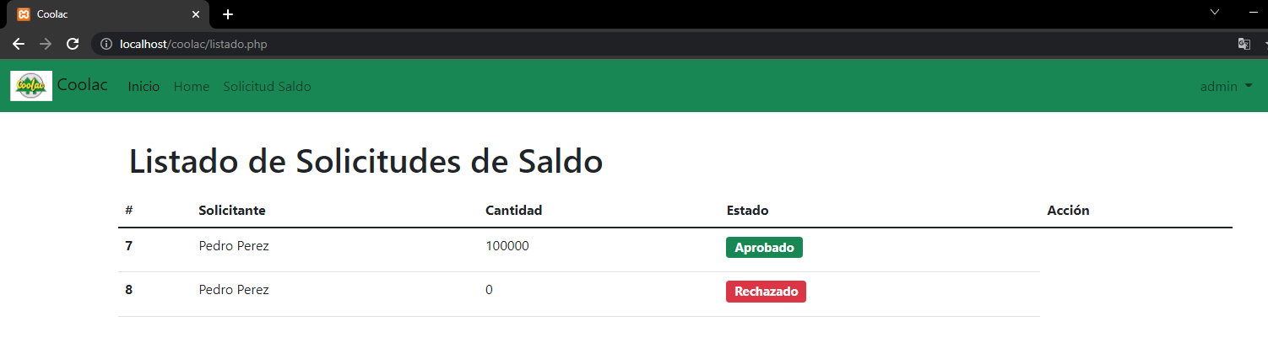

As we can see in the following image, the user's balance has increased.

